# Arithmetic Challenge – User Manual

This application was made to allow instructors to be able to assess their students’ knowledge on basic mathematic operations over a network.

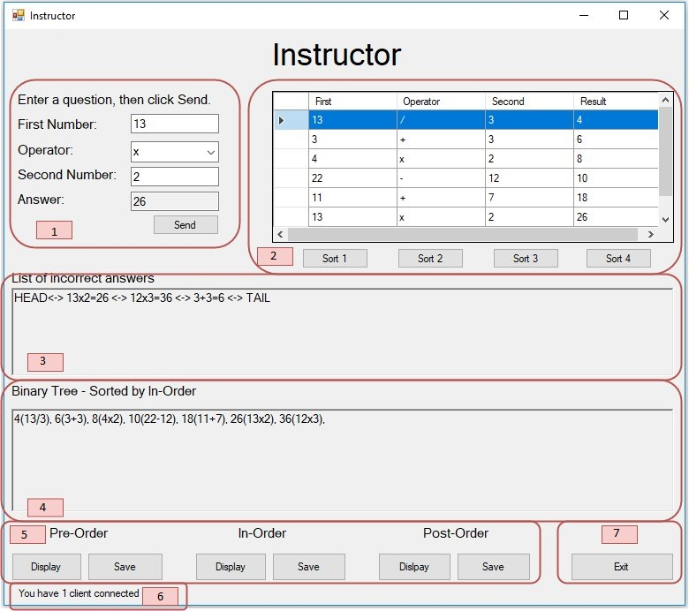

(Image 1.0 – User Interface)

The instructors interface can be broken up into 7 sections:

* Image 1.0 – Section 1: This section is where the instructor types in the desired question which will be sent to the student. The fields and buttons in this section are:
  1. First Number – the first number of the equation
  2. Operator – The mathematical operations available are addition, subtraction, multiplication and division.
  3. Second Number – The second number of the equation
  4. Answer – displays the answer live to the instructor
  5. Send Button – When the desired equation is entered click this button. You will not be able to press this button again until the student has sent the reply.
* Image 1.0 – Section 2: This section displays a list of all questions asked. The sort buttons available sort each column displayed above the button. If the button is clicked once all items will be displayed in ascending order for that column. If it is selected a second time, all items will be displayed in descending order.
* Image 1.0 – Section 3: This text box displays a link list of all results incorrectly answered by the student
* Image 1.0 – Section 4: This text box displays a print out of the binary tree created for every question asked. The data shown in here is controlled by the buttons in Section 5.
* Image 1.0 – Section 5:
  1. Pre-Order
     1. Display Button: Displays the binary tree results in a pre-order layout in the binary tree text box above the buttons.
     2. Save Button: Saves the pre-order layout to a text file for later use.
  2. In-Order
     1. Display Button: : Displays the binary tree results in an in-order layout in the binary tree text box above the buttons.
     2. Save Button: Saves the in-order layout to a text file for later use.
  3. Post-Order
     1. Display Button: : Displays the binary tree results in an post-order layout in the binary tree text box above the buttons.
     2. Save Button: Saves the post-order layout to a text file for later use.
* Image 1.0 – Section 6: Displays how many students are connect.
* Image 1.0 – Section 7: The Exit button closes the instructor window finishing the session.

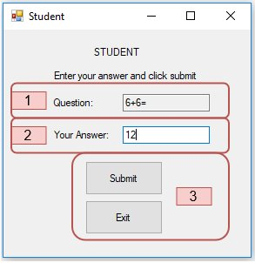

(Image 2.0 – Student List Window)

* Image 2.0 – Section 1: The question sent from the instructor will be displayed in this text box.
* Image 2.0 – Section 2: This is where the student types in the answer to the question.
  1. If the reply is incorrect, the student will be displayed the following message (Image 3.0).

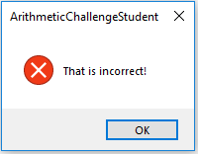

(Image 3.0 – Incorrect Answer)

* 1. If the reply is correct, the student will be displayed the following message (image 4.0)

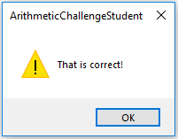

(Image 4.0 – Correct Message)

(Image 3.0 – Dialog Window)

* Image 2.0 – Section 3:
  1. The Submit button will only become available when a question is received and will again become unavailable when the reply is sent back to the instructor.
  2. The exit button closes the student window, but it does not finish the session. If the student reopens the window, it will reconnect to the instructor application.